OPERATION KUJARI STABILISATION OPORD

Saturday, July 15th 2007



Please be nice to me

**TASK ORGANISATION** **5**

**Situation** **6**

Area of Operations 6

Terrain 7

Weather 8

Areas of Interest 9

Marwey Airfield 9

Marwey 9

Mimi 9

Wondori 9

Kaoya 9

Enemy Forces 9

Composition, Disposition, and Strength 9

Recent activities 10

Locations and Capabilities 11

Enemy COAs 11

Friendly Forces 11

Higher HQ Mission and Intent 11

Mission of Adjacent Units 12

Attachments and Detachments 12

Civil Considerations 13

**Mission** **15**

**Execution** **15**

Commander’s Intent 15

Concept of Operations 15

Manoeuvre 15

Fires 16

Reconnaissance and Surveillance 16

Intelligence 17

Engineer 17

Information Operations 17

Scheme of Movement and Manoeuvres 17

Reaction to Fire 17

Phase 1 21

Phase 2 23

Casualty Evacuation 25

Coordinating Instructions 25

Time or Coordination 25

Rules of Engagement 26

**Sustainment** **26**

Logistics 26

Transportation 26

Supply 27

Army Health System Support 27

Medical Treatment 27

**Command and Control** **28**

Signal 28

SOI Index in Effect 28

Pyrotechnics and Signals 28

Code Words 28

Running Password 29

**Appendix/Glossary** **30**

# TASK ORGANISATION

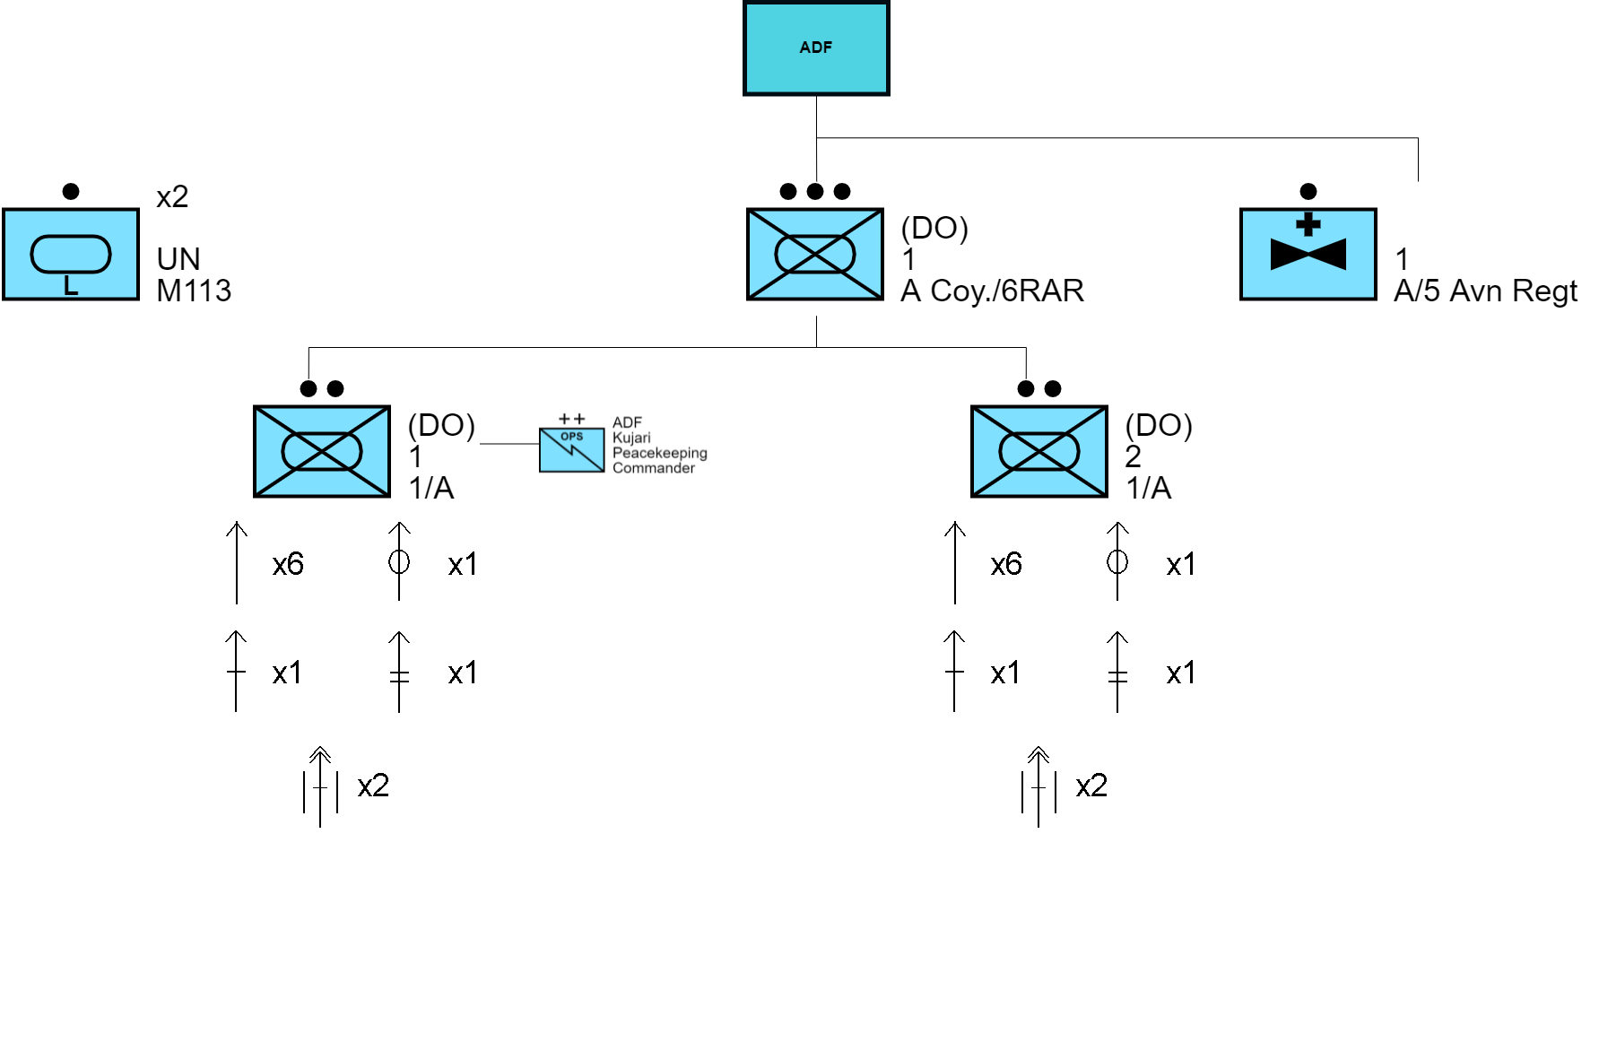

*All times used in the document are local time (GMT+1) unless stated otherwise.*

# Situation

## Area of Operations

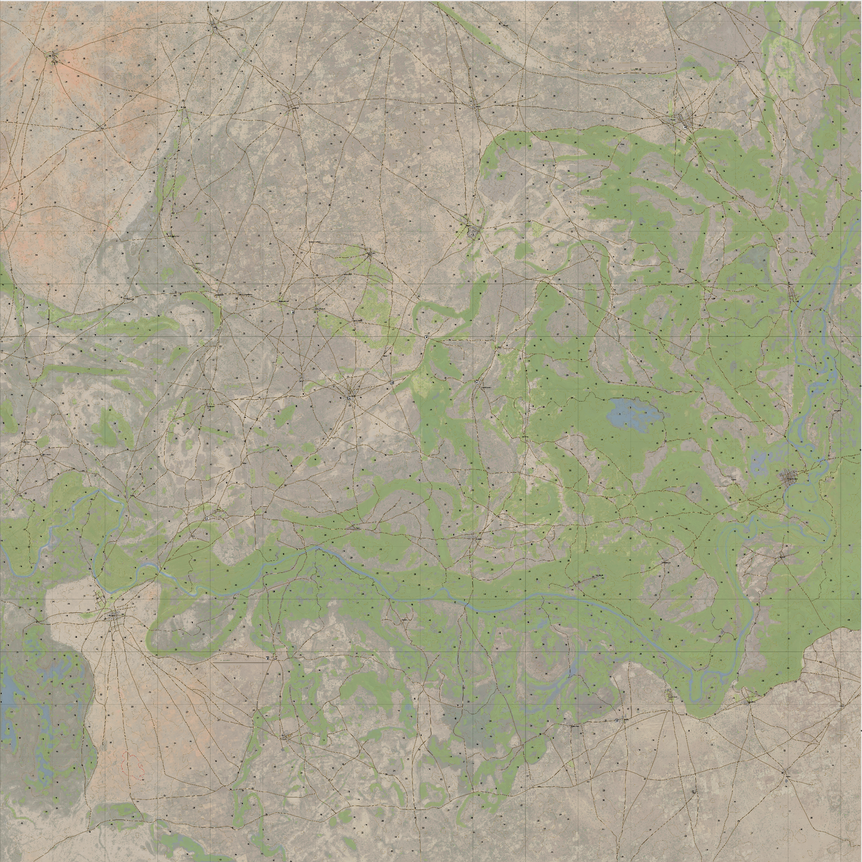  
Kujari -[https://jetelain.github.io/Arma3Map/kujari.html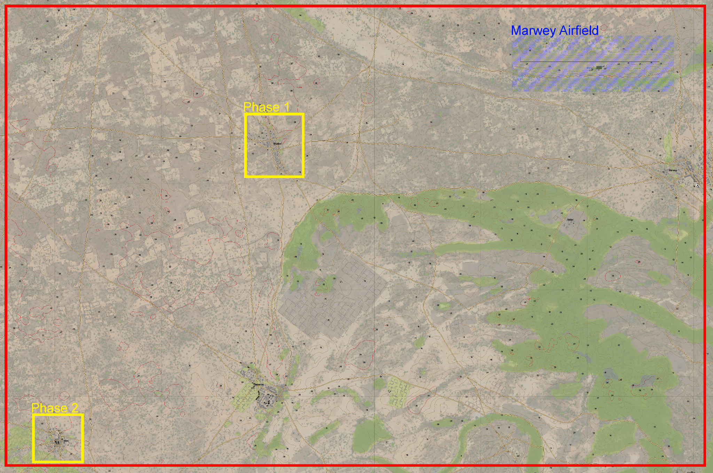](https://jetelain.github.io/Arma3Map/kujari.html) Area of Operations

### Terrain

The terrain of the Sub-Saharan nation of Kujari, one of the smaller nations of the world (being approximately 16km2), is relatively flat with small hills and valleys with maximum elevations of approximately 40 metres. This terrain flatness generally provides a 360° field of fire. Vegetation density and ground type fluctuates within the region with the majority being dry plains to the north and south with spread trees. There are denser vegetated areas to the east with a strip that runs Westward in the southern half of the nation. The denser areas tend to have greater variation in topography. The tree cover on the south of the airfield may provide concealment on the avenue of approach towards the objective. To the far North-West the terrain is slightly dryer and flatter than the majority of the landscape as well as having scarcer trees.

The large majority of buildings and villages in Kujari are walled compounds with small one-to-two story buildings made primarily from mud, dirt, or sandstone. Additionally there are a small proportion of smaller wooden and tin structures that are often seen in slums and third-world countries. There are a small number of concrete buildings, such as stores, and larger buildings in major cities. Almost **all** roads in the nation are crude and made of dirt which often causes mechanical failure of vehicles and vehicle collisions. Water is sparse in the region. The one major river runs through the centre of the country going East-to-West before turning NE-to-SW on the Western side of the terrain. In addition to the main river are a few smaller sized lakes and marshes in the more densely vegetated areas.

Small to medium sized rocks, trees, and hills provide minimal but effective cover in the event a unit comes into contact.

### Weather

Being in Central Africa, Kujari is hot and dry generally with temperatures averaging above 32°C by midday. The dry heat is currently intensified as rainfall has been extremely low from June through August. The region gets approximately 12 hours of daylight on average. Cloud cover and winds are forecasted to be minimal on the day of operations. The combination of these two effects should provide maximum visibility. This works both for and against friendly forces as both sides will have extended visibility ranges, allowing us to both spot, and be spotted from a distance.

The high heat and scarcity of water increases the chances of hyperthermia and dehydration to dangerous levels. To ensure the suppression of this effect all units **must** carry sufficient amounts of water.

## Areas of Interest

### Marwey Airfield

MOB of UN and Australian peacekeeping forces.

### Marwey

Capital city of Kujari, and in close proximity to Marwey Airfield

### Mimi

Small Village, main village for cultural gatherings and ceremonies for most of Kujari

### Wondori

Medium town, recent target of KNFA IED bombing and attack and current location of IDAP Aid Point

### Kaoya

Small Village, recent target of KNFA militia attack

## Enemy Forces

### Composition, Disposition, and Strength

The Kujari National Freedom Army (KNFA) is an organised militia force operating in the nation of Kujari. After the nation’s official government collapsed in early May of this year, the lack of control in the area has given room for multiple militias and rebel groups to attempt the taking of control of Kujari. Currently, the largest group is the KNFA which controls 80% of the region, excluding 20% of the South East.

The KNFA has been noted as extremely hostile towards UN peacekeeping forces since their arrival in the previous month.

The UN estimates the strength of the KNFA is approximately 2,000 men, and are in possession of small-arms such as assault rifles, light vehicles including improvised armoured vehicles, shoulder fired munitions, and often use IEDs crafted from unexploded ordnance disguised as often seen items like rubbish piles, market stalls, and vehicles, which should be expected. The KNFA has the habit of conducting secondary attacks after use of IEDs, commonly using these as precursors to ambushes.

### Recent activities

Recently, the KNFA has launched multiple attacks on the cities of Wondori, Marwey, and Kaoya. UN reports from the recent Kaoya attack say that the KNFA used at least 3 (three) IEDs to create chaos before conducting a secondary raid on the town to collect money, harvest crops, and taking women and children in a violent attack.

KNFA has released multiple statements on neighbouring countries’ news stations claiming responsibility for many violent acts in the nation and surrounding regions, as well as nominating themselves as the official leaders of the Kujari nation.

### Locations and Capabilities

The primary location of the KNFA is unknown. It is believed that they mostly reside in the direct North of Kujari, allowing them access to the southern regions of neighbouring countries, although their strength is spread through the majority of the region.

The militia is improperly trained but efficient with their weapons after civil wars in previous decades. They can however, react to and reinforce positions extremely quickly with response times near 6 minutes anywhere inside the nation.

### Enemy COAs

Due to the infancy and ongoing development of the KNFA, their general COAs and tactics are relatively unknown. Their recent actions are reasonably similar to other regional Central African guerillas. The majority of their actions are reactionary, usually resistance actions to keep civilians or foreign forces from intervening. Previous UN outreach attempts have resulted in destruction of infrastructure, sustenance interference, and acts of terror, including the execution of individuals deemed likely to resist their regime.

## Friendly Forces

### Higher HQ Mission and Intent

The overall mission and intent of the joint peacekeeping force is to restore order to the nation of Kujari until a stable government can be re-established. This is achieved by UN peacekeeping forces being positioned adjacent to Australian Defence Forces to deter militia and rebel attacks on villages and towns. The UN, in conjunction with IDAP, will provide nation-wide security and aid to villages and towns when safe to do so.

### Mission of Adjacent Units

In addition to 1st Platoon A Coy. 6RAR stationed at Marwey Airfield in Kujari, 8/9RAR is stationed at the closest neighbouring country to the NE on standby for support or to aid in the importation and distribution of supplies to in-country units, if necessary. Accompanying 8/9RAR is 2nd Platoon, A Coy., 6RAR manning security positions along the NE Nation’s border. These units provide security to the border of the country in attempts to stop KNFA members from crossing into neighbouring nations.

## Attachments and Detachments

For a majority of Operation Kujari Stabilisation 1st and 2nd Sections, 1st Platoon, A Coy., 6RAR will have 1 (one) Journalist from Eastern Post News attached to them for reporting on Australia’s Peacekeeping efforts in Kujari. 3rd Section of 1st Platoon, A Coy., 6RAR is stationed further south in the nation at FOB Matilda, deterring rebel attacks to continue south into the country.

3rd Platoon, A Coy., 6RAR is on R&R at Gallipoli Barracks, Enoggera, QLD, from their recent deployment to Timor Leste in South-East Asia, and therefore will not be deploying with 1st and 2nd Platoon.

The final attachment integrated with 1st Platoon A Coy. 6RAR is the current commanding Australian officer in Kujari. He will be embedded with the 2nd Section for manoeuvres throughout the operation.

| Unit | Attachment |
| --- | --- |
| 1st Section | Eastern Post News Journalist |
| 2nd Section | ADF Kujari Peacekeeping Commander |

## Civil Considerations

The religious majority of Kujari became Sunni Islamic after Northern invasions during the late 19th century. Due to this, Islam is practiced in conjunction with traditional African morals, beliefs and ceremonies. Because of this, raiding of mosques is strictly prohibited no matter the situation. The primary language of the country is Arabic to coincide with the official religion of the country. In a majority of towns and villages there is at least 1 (one) English speaking person available for translation.

Due to Kujari being an extremely impoverished country, population density is quite high compared to the majority of first world countries. Motor vehicles are largely sparse, but of the vehicles that there are, failures are highly common, resulting in frequent traffic collisions and stranded roadside drivers. Many residents of the country spend their time farming crops and animals, and selling their goods at stores and roadside markets to make small amounts of money to sustain their minimalist lifestyles.

Other than militias and rebel groups in the country, youth gangs are a large epidemic in the South-Western region, slowly spreading North. Illegal production and distribution of alcohol and narcotics are rampant throughout the region and are suspected to be the main income for the KNFA.

Civilians have often appeared moderately hostile to the UN peacekeepers. Informational sources have related this to fear of KNFA retaliation due to accepting aid from foreign sources.

# Mission

Two sections will mount APCs to travel SE to Wondori to provide supplies to IDAP members NLT 1030 hours July 21, immediately after which the platoon will travel further SE to Mimi to garner information on the KNFA and conduct a hasty search of village for any signs of militia conduct.

# Execution

## Commander’s Intent

The intent of the operation is to garner information about KNFA to assist in the deterrence and ultimate disbanding of the militia group. In conjunction with this it is aimed to provide logistical replenishment to the IDAP Aid Point in Wondori. These two acts will establish a foothold in the nation as our initial infiltration to the country, and create an identity of strength and protection for the community, whilst intimidating the militia group.

Success for the operation will be marked after significant and important information has been learned about the opposing forces, and when sufficient aid resupply has been provided to the IDAP Aid Point.

## Concept of Operations

### Manoeuvre

Both sections will move through the operations inside their 2 (two) respective M113 APCs. This will allow adequate movement speeds and higher terrain capability than wheeled vehicles. The small size of the country, as well as the short distance to be travelled in this operation make the M113 more than capable of mission duties inside the Area of Operations.

On main and rural roads outside of towns and villages coalition vehicles are limited to a speed of 60km/h, which is close to the maximum capable speed of the M113 on flat ground. When passing obstacles or civilians on the roads outside towns, ADF vehicles have been given a speed limit of 40km/h.

Inside of towns and villages vehicles can travel no faster than 25km/h, though slower is recommended to avoid vehicle-vehicle or vehicle-person collisions.

### Fires

Each section is outfitted with 2 (two) M72 LAW Anti-Tank Weapons, 1 (one) F89 Minimi LSW Machine Gun, 1 (one) MAG 58 MSW Machine Gun, 6 (six) F88 Austeyr Assault Rifles, and 1 (one) F88GLA Austeyr Assault Rifle.

No FSA or CAS will be available for the duration of this operation.

### Reconnaissance and Surveillance

A UN Mi-8T helicopter will be doing regular flyover surveillance of the area for supply deliverance, intelligence gathering, and SAR operations.

Because of the proximity of this aircraft to the platoon’s area of operations, the aircraft will be in regular contact with the commanding officer attached to the platoon.

### Intelligence

All available intelligence known about the KNFA will be provided to section commanders prior to commencing of the mission. This will be passed down through sections at section commander discretion.

### Engineer

Each section has one mechanically trained rifleman to assist in the changing and repairing of M113 pieces, in the event that mechanical failure occurs.

### Information Operations

Due to this being the initial information operation by ‘foot soldiers’ on the ground in Kujari, no other information operations have been conducted. The only operations have been aerial scans and conversing with former soldiers of the Kujari National Armed Forces.

## Scheme of Movement and Manoeuvres

### Reaction to Fire

It is required that at least 1 (one) soldier stays with their section’s assigned vehicles at all times, however it is suggested that 2 (two) stay with the vehicle. The gunner and driver crew members of the APCs will provide security, and immediate mobility to the vehicles. Stationary dismounted units from the vehicles must attempt to provide 360° of security for the vehicle in the open, and 180° against a wall.

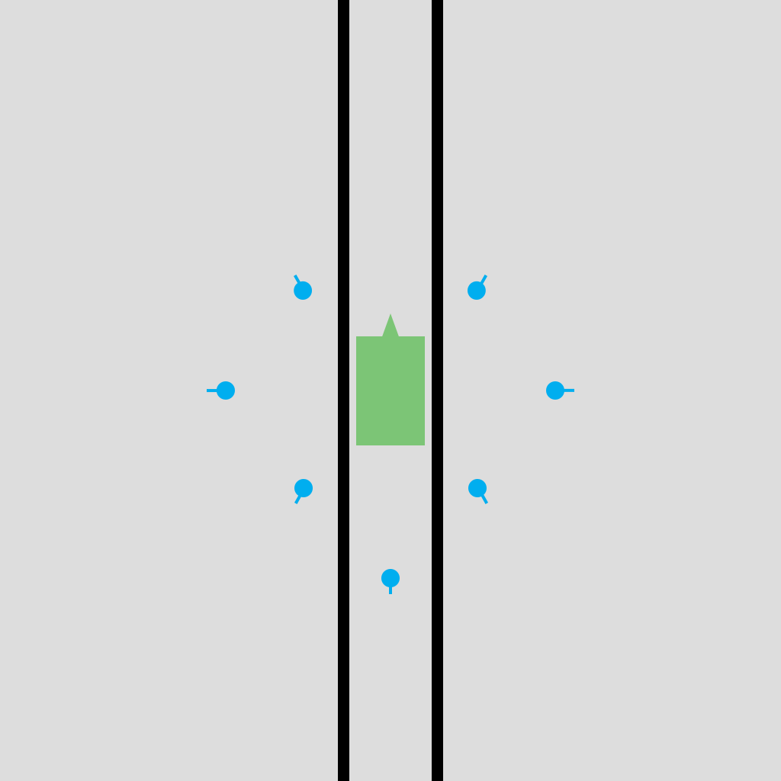

**

When reacting to fire whilst mounted inside the section’s vehicle, the vehicle’s gunner should immediately return fire on the enemy via the vehicle’s mounted weapon system. Troops in transportation should attempt to dismount, if safe to do so, and establish 360° of security for the section and return fire upon the enemy.

In the event a section’s vehicle is struck by a shoulder fired munition, IED, or other debilitating weapon, the units inside said vehicle should immediately attempt to exit the vehicle and move themselves a safe distance from the explosion site to avoid the effects of secondary explosions and ‘cook off’ from the vehicle’s stored ammunition. If heavy fire is experienced the unaffected section may provide additional security on the affected vehicle by dismounting their vehicle and covering sectors of fire. Critically injured units should be loaded into the unaffected vehicle with a combat paramedic for assisted treatment.

The secondary vehicle’s gunner should simultaneously begin scanning for threats in the surrounding areas, while communication is made with the dismounted units of the lead vehicle. If the vehicle is established to still be operationally functional, the affected section should re-mount and evacuate as quickly as possible, whilst treating patients as efficiently as possible.

* + 1. Map Positions

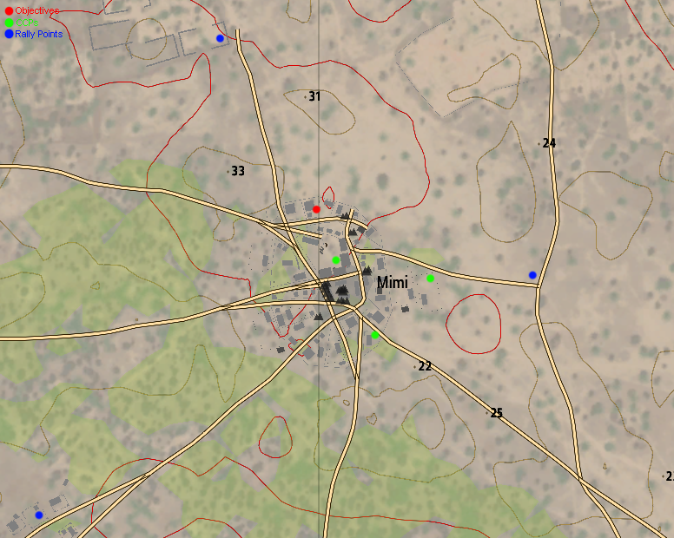

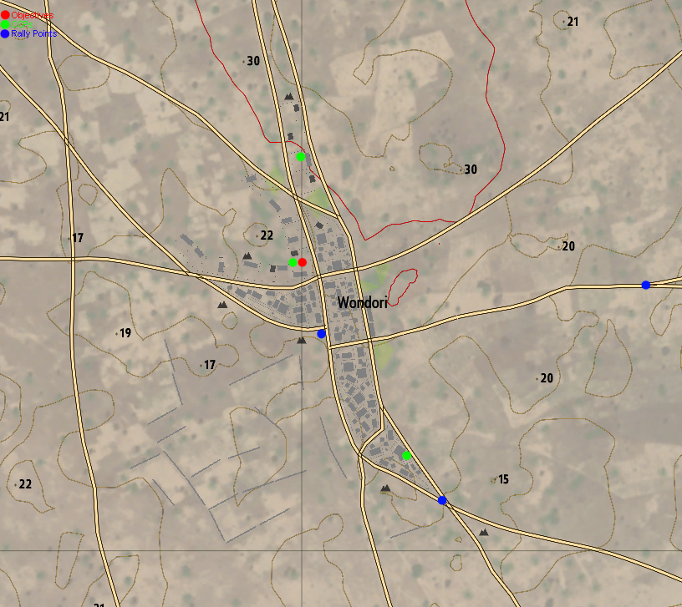

### **Phase 1**

At 0940 hours, 1st and 2nd Sections, 1st Platoon of A Coy., 6RAR, RAINF will prepare their equipment for the day's two phase operation, their first operation in country. Commencing NLT1030 hours the platoon will load 12 (twelve) boxes of medical supplies into their 2 (two) M113 APCs and travel East along the main road from the Marwey Airfield, which is the primary airport for Kujari and the current MOB for Australian and UN troops.

2nd Section, accompanied by Australia’s Kujari Peacekeeping Commander, will mount into the lead vehicle to commence operations. Simultaneously, 1st Section, accompanied by a journalist from Eastern Post News, will mount into the rear vehicle to commence operations.

Travelling East, the platoon will continue until the crossroad at grid reference 100155 at which point they will redirect South-East to the town of Wondori, where an IDAP Aid Point is set up to treat casualties from a KNFA attack in the previous days. Here, the platoon will unload the aid boxes from the APCs at the aid station. At this point, Phase 1 will come to completion.

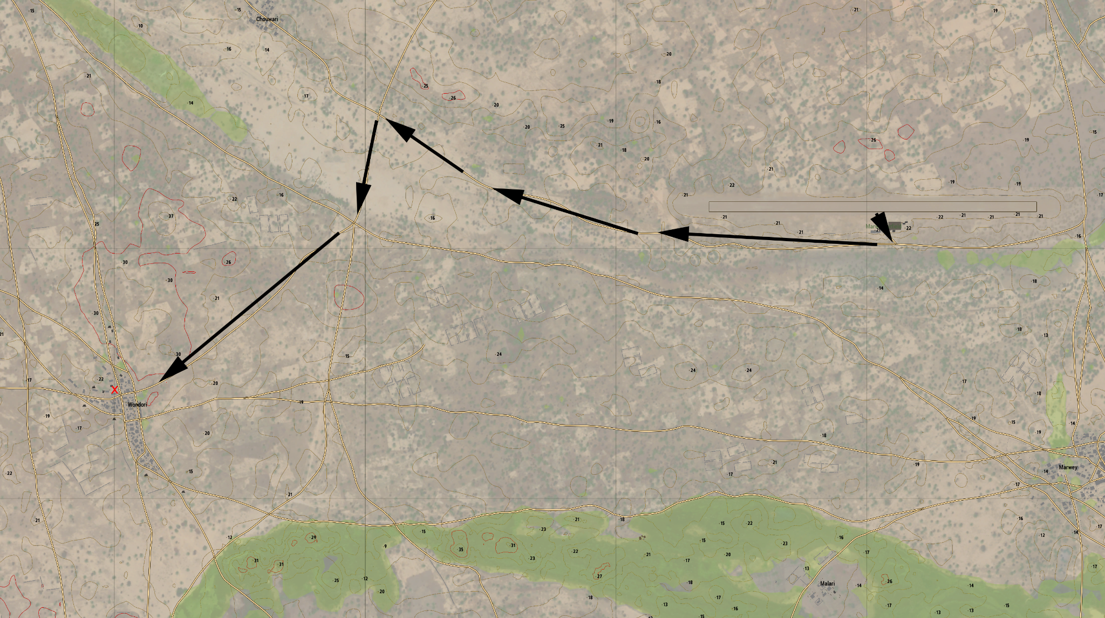  
 Phase 1 Movement

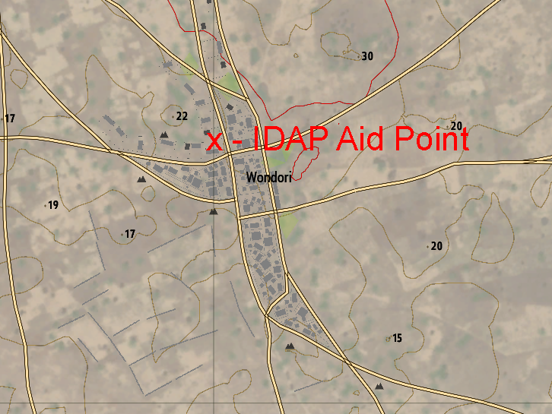 *Wondori*

### **Phase 2**

After completion of Phase 1, the platoon will then remount in the APCs and continue East on the main road. When the platoon reaches the crossroad at grid reference 073145 they will redirect South for approximately 3km to the village of Mimi. In the village, a nominated section commander will converse with the main elder of the village to garner information on the KNFAs. It is understood that a resident in the town speaks English and will be available to translate for the platoon in conversation with the village elder.

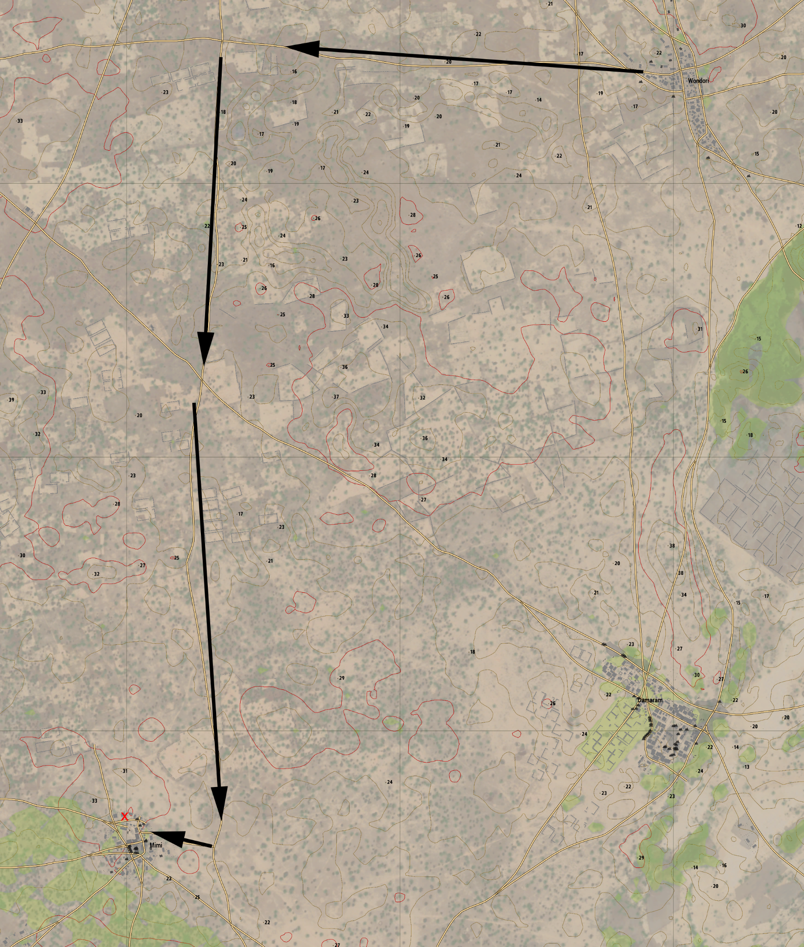  
 Phase 2 Movement

*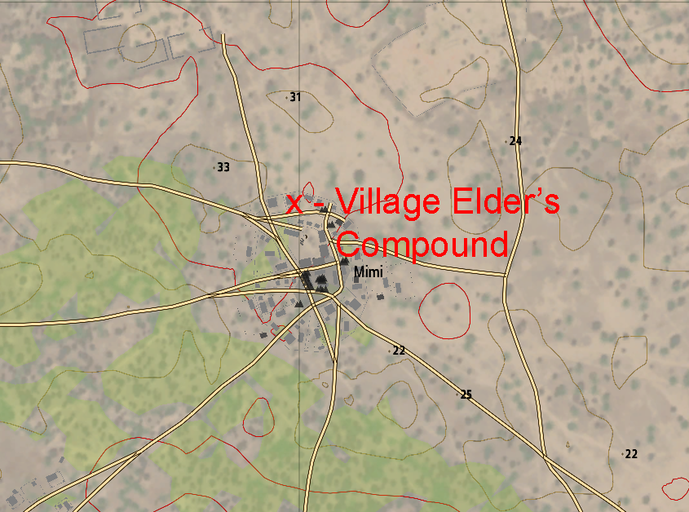  
 Mimi*

After conversing with the village elder, the platoon will do a security check of the town, looking for evidence of KNFA activity. The platoon will call in any findings to TOC at the MOB and then return to the MOB at the Marwey Airfield. Return of the platoon to the MOB will mark the completion of Phase 2, at which point the platoon will conduct their BDA and AAR.

## Casualty Evacuation

The plan for medical and casualty evacuation remains the same through all phases of the operation. Non-urgent casualties will be treated to the unit’s best effect and transported back on the same vehicle they were infilled with.

In the event of emergency casualty evacuation, 2 (two) UN M113 APCs are stationed in Wondori and will be available for emergency transportation back to Marwey Airfield.

In extreme emergencies it is possible that 1 (one) UH-60 BlackHawk will be available from neighbouring countries for transport and casualty evacuation.

## Coordinating Instructions

### Time or Coordination

It is imperative to the success of this mission that gear and equipment is organised NLT 1030 hours. To do this, organisation and preparation should commence at 0940 hours. This allows adequate time for briefing and checking of equipment and weapon systems.

### Rules of Engagement

* Australian Defence Forces have the right to **defend** themselves against **attacks or threats of attack**
* Hostile fire may be returned effectively and promptly to stop a hostile act
* If under attack by an unarmed party, hostile element, riot and/or mobs, Australian Defence Forces should use the **minimum force** necessary under the circumstances and **proportional** to the threat.
* Australian Defence Forces **may not** seize the property of others to accomplish their mission.
* Detention of civilians is **authorised** for security reasons or in self defence.

1. Australian Defence Forces are present for *peacekeeping* and are **not** at war.
2. Treat all persons with dignity and respect.
3. Use minimum force to carry out missions.
4. Always be prepared to act in self defence.

# Sustainment

## Logistics

### Transportation

Due to the mechanised nature of 6RAR, the majority of transport will be self provided by the assigned armoured vehicles. There are exceptions to this in cases of casualty extraction, or mechanical failure.

### Supply

Each section’s M113 APC will be equipped with sufficient supply and replenishments to sustain deployed troops for the duration of the operation, in addition to further sustainment.

Soldiers equipped with the F88 Austeyr assault rifle are required to carry a **minimum** of 180 *(6x 30 round magazines)* rounds of ammunition on their person. MSW and LSW gunners are required to carry a **minimum** of 600 rounds *(3x 200 round boxes or 4x 150 round boxes)*. Each section’s 2iC is **required** to carry a digital photo camera for image proof of evidence in searches. This item will be in replacement of the individual’s binoculars.

Section commanders should carry a GPS navigation system on their person at all times to aid in precise positional tracking of the section. This will aid in communication and land navigation.

## Army Health System Support

### Medical Treatment

Each section has 1 (one) combat paramedic in charge of the section’s health and casualty triage. Section medics are responsible for their own equipment and medication supplies to provide sufficient care to combat and non-combat paramedics. New equipment may be provided to sections upon request of the section medic to ensure there is an available readiness. If an individual is injured they should practise company SOPs and provide self aid to the best of their abilities.

# Command and Control

## Signal

### SOI Index in Effect

| **Frequency** | **Use/Callsign** |
| --- | --- |
| 30.000 | Command Communication |
| 40.000 | Inter-Vehicle Communication |
| 50.000 | Inter-Section Communication |
| 51.000 | Wombat 1-1 Communication |
| 52.000 | Wombat 1-2 Communication |

### Pyrotechnics and Signals

Signalling friendly positions, enemy positions, and others will be done primarily with coloured smoke. Red smoke will signify enemy positions, green smoke will signify friendly positions, purple smoke will signify extraction positions, and blue smoke will signify Casualty Collection Points (CCPs).

### Code Words

For OPSEC purposes and to avoid information leaks in case of transmission interception, attachments will be assigned code words to be referred to over telecommunication. This list will be provided to each section commander prior to the operation. The ADF Kujari Peacekeeping Commander will be referred to as *“Emu”*. The attached journalist will be referred to as *“Bucket”*.

Certain codewords will be used for situations that may arise during this operation that could compromise the security of units. If a unit suspects or comes into contact with militia members, they will use the code word *“preach”*. The code word for a suspected or confirmed IED is *“scarecrow”*.

All codewords should be used in a phrase and not as individual words. This will aid in avoiding confusion on what is and is not being used as a code word.

e.g. **A unit suspects an IED on an upcoming road:**

**Wombat 1-1:** *“1-1 this is 1-2…”*

**Wombat 1-2:** *“Go for 1-2.”*

**Wombat 1-1:** *“It looks like we might have a scarecrow up ahead…”*

### Running Password

The commander, or section commanders in conjunction with each other, may also request that their unit use a ‘running password’, to be used for fast approaching friendly units in less-than organised manners, such as under fire or other types of pressure.

# 

# Appendix/Glossary

| Noted As | Intended Meaning |
| --- | --- |
| 2iC | Second (2nd) in Command |
| ADF | Australian Defence Force(s) |
| APC | Armoured Personnel Carrier |
| AAR | After Action Review |
| Battalion | A military unit consisting 2-3 Companies, totalling in approximately 300-1,000 soldiers |
| BDA | Battle Damage Assessment |
| CAS | Close Air Support |
| CCP | Casualty Collection Point |
| COA | Course of Action |
| Coy., Company | A military unit consisting 2-3 platoons, totalling in approximately 80-250 soldiers |
| FOB | Forward Operating Base |
| FSA | Fire Support Asset |
| GLA | Grenade Launcher Attachment |
| HQ | Headquarters |
| IDAP | The International Development & Aid Project |
| IED | Improvised Explosive Device |
| In-Country | Being or taking place in a country that is the focus of activity |
| Km/h | Kilometres-per-hour |
| KNFA | Kujari National Freedom Army |
| LSW | Light Support Weapon |
| MSW | Medium Support Weapon |
| M113 | A fully tracked armoured personnel carrier used as an APC by the Australian Army |
| MOB | Main Operating Base |
| Militia | A military force that is raised from the civil population |
| NLT | No Later Than |
| OPSEC | Operational Security |
| Peacekeeping | Activities intended to create conditions that create and continue a state of peace |
| Platoon | A military unit consisting of 2-4 sections and approx. 20-50 soldiers |
| QLD | The state of Queensland |
| 6RAR, 8/9RAR | 6th Battalion Royal Australian Regiment, 8th/9th Battalion Royal Australian Regiment |
| RAINF | Royal Australian Infantry |
| RTB | Return To Base |
| SAR | Search and Rescue |
| Section | A military sub-unit consisting of 7-10 men |
| SOI | Signal Operating Instructions |
| Sub-Saharan | The area of the continent of Africa that lies south of the Sahara. |
| TOC | Tactical Operations Control |
| UN | United Nations |